Studio in Ceramics
Digital Portfolio

Every student has a folder located in Classes/ Pountain/ Ceramics. This is your digital portfolio. All of your work needs to be photographed and organized in your individual folder.

Requirements:
- Include a minimum of 2 (sometimes three is better) views of each piece that you created.
- Make sure that your piece is filling the frame and that it is in focus.
- Use a neutral background with a light or take the pictures outside using natural light.
- Make sure the piece is the focus!
- You may use the camera here at school or your own.
- Make sure each image is titled, numbered and saved as a jpeg.
  - Example:
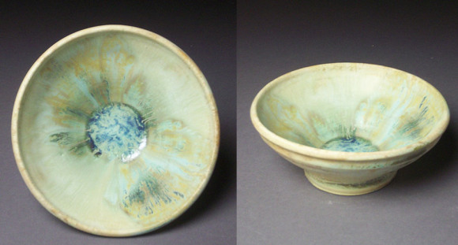
Thrown Bowl1.jpg Thrown Bowl2.jpg
- Make folders for each quarter and each project.
    - Mike Smith
      - Quarter 1
        - Kiln God
        - Pinch Pot
        - Tea Bowls
        - Ocarina

* It is important that you take pictures throughout the semester so that you are not scrambling to get this done at the end of each quarter.

